**LAB # 3: Connected Component Analysis**

**Lab Objective:**

The objective of this lab to perform connected component labelling in images and to get an understanding of intensity level resolution.

**Lab Description:**

**Connected Component Analysis** or Labelling enables us to detect different objects from a binary image. Once different objects have been detected, we can perform a number of operations on them: from counting the number of total objects to counting the number of objects that are similar, from finding out the biggest object of the bunch to finding out the smallest and from finding out the closest pair of objects to finding out the farthest etc.

Connected Component labelling procedure is as follows:

* Process the image from left to right, top to bottom:

If the next pixel to process is 1

i.) If only one from top or left   
 is 1, copy its label.

ii.) If both top and left are one and have the   
 same label, copy it.

iii.) If top and left they have different labels

− Copy the smaller label

− Update the equivalence table.

iv.) Otherwise, assign a new label.

* Re-label with the smallest of equivalent labels

Video explanation: https://www.youtube.com/watch?v=ticZclUYy88

**Some Useful Commands:**

1. arr = np.array( [ [ 1, 2, 3 ] , [ 6, 5, 4 ] ] )

arr + 2 will add 2 in each element of arr

1. arr = np.array( [ [ 1, 2, 3 ] , [ 6, 5, 4 ] ] )

arr == 2 will return following bolean array

array( [ [ False, True, False] , [ False, False, False ] ] )

**Lab Task:**

For the image given below (provided with the lab handout), apply the connectected component labelling and count the total number of white objects. First threshold the images ( replace pixel values less than 127 equal to 0 and above 127 equal to 1) and then do connected component analysis.

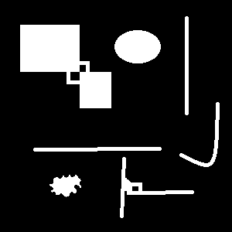

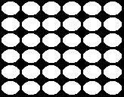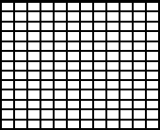

1. (b) (c)

**THINK!!**

1. Can we apply connected component analysis any image without doing any preprocessing?
2. How can we optimize this process?
3. Why the code took more time to do connected component analysis for image b than image a?
4. Is it possible to count objects which are inside an object using connected component analysis?